Florida Instructional Materials Center for the Visually Impaired (FIMIC-VI)
https://www.fimcvi.org/
4210 W Bay Villa Ave Tampa, FL 33611
813-837-7826
800-282-9193
Liz Anderson, Program Coordinator
eanderson@fimcvi.org

FIMC-VI provides services to students with visual impairments enrolled in Florida’s public and private schools as well as
those students that are home schooled if they are participating in a “formally organized educational program”. FIMC-VI also supports all teachers, school administrators, and agency personnel working with Florida’s K-12 students with visual impairments.

SEDNET
372 W. Duval Lake City, FL 32055
Dana Huggins
hugginsd@columbiak12.com
386-755-8191

Coordination of services for children with or at-risk of emotional/behavioral disabilities and their families by assisting multi-agency collaborative initiatives to identify critical issues and barriers of mutual concern and develop local response systems that increase home and school connections and family engagement.

UF CARD: Center for Autism and Related Disabilities
www.card.ufl.edu
4101 NW 89th Blvd. Gainesville, FL 32606
352-265-2230
card-info@ufl.edu

UF CARD Gainesville provides the following services, free of charge: training, technical assistance to schools/districts, consultation to parents and care providers, resource referral, and public education.

Hamilton County School District
Exceptional Student Education Staff

Annie Pinello, Coordinator of Exceptional Student Education
annie.pinello@hamiltonfl.com
386-792-7851

Selina Jones, Staffing Specialist
Serving Hamilton Co. Elementary
selina.jones@hamiltonfl.com
386-792-7853

Renee Daigle, Staffing Specialist
Serving Hamilton Co. High School
renee.daigle@hamiltonfl.com
386-792-7854
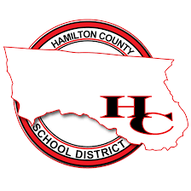

Social Security Benefits
www.socialsecurity.gov
1348 SW Bascom Norris, Lake City, FL 32025
800-325-0788

Services: Supplemental Security Income (SSI), Supplemental Security Disability Insurance (SSDI), employment support programs, Medicaid, Medicare, Children’s Health Insurance Program, other health care services

Division of Vocational Rehabilitation Unit 05CA
http://www.rehabworks.org/
100 Court St. SE, Live Oak, FL 32064-4817
Shakelia Epps, Supervisor
shakelia.epps@vr.fldoe.org
Tawana Gilbert, Area Director
Tawana.Gilbert@vr.fldoe.org
386-362-5461
Works with people who have physical or mental disabilities prepare for, gain, or retain employment and find meaningful careers.

CareerSource - North Florida
https://careersourcenorthflorida.com/
850-973-9675
1558 Ohio Avenue South, Live Oak, Fl 32064
Provides a full array of employment and training related services for job seekers, workers, youth, and businesses. May include Disability Program Navigators, Vocational Rehabilitation counselors and Veterans Services on-site

Job Corps - Gainesville
https://gainesville.jobcorps.gov/
352-377-2555
5301 NE 40th Terrace, Gainesville, FL 32609
Provide comprehensive residential education and job training for youth ages 16 through 24; the upper age limit may be waived for applicants with disabilities. Training accommodations are available. Students are usually matched with programs in their interest areas and near their residences.
Agency for Persons with Disabilities
https://apd.myflorida.com/
352-955-6199
Jennifer Fennell
Jennifer.fennell@apdcares.org
Supports persons with developmental disabilities (spina bifida, autism, cerebral palsy, Prader-Willi syndrome, and mental retardation) in living, learning, and working in their communities.

The Arc North Florida
https://www.arcnfl.com/
511 Goldkist Blvd SW Live Oak, FL
386-362-7143
Denise Perry, ADT Supervisor (Hamilton Location)
386-792-3454

The Arc North Florida plays an active role in meeting the needs of all people with developmental disabilities. Their mission focuses on helping to develop supports necessary for people to live independently and become a more integral part of the community. Service locations include the Administrative Office, Adult Day Training facility, and
residential facilities located in Live Oak, and the Adult Day Training facilities in Macclenny and Jasper.

Brain and Spinal Cord Injury Program
http://www.floridahealth.gov/provider-and-partner-resources/brain-and-spinal-cord-injury-program
4052 Bald Cypress Way, Bin C25
Tallahassee, FL 32399
850-245-4045
800-342-0778

The Brain and Spinal Cord Injury Program (BSCIP) is administered by the Florida Department of Health. The program is primarily funded by the Brain and Spinal Cord Injury Program Trust Fund, as outlined in section 381.79, Florida Statutes. These funds are appropriated to the department for the purpose of providing the cost of care for brain or spinal cord injuries as a payor of last resort to residents of this state. The program also receives state general revenue funding as well.

Center for Independent Living
www.cilncf.org
Program Dir. Linda Butler: lbutler@clincf.org
Assoc. Dir. Amy Tharpe: Amy@cilncf.org
352-378-7474 ext. 25

Services: advocacy, information & referral, independent living skills, peer support, and transition.

Children’s Medical Services (CMS) - Gainesville
http://www.floridahealth.gov/
Stephanie Cox, Term Coordinator stephanie.cox@flhealth.gov
352-627-5077
1699 SW 16th Avenue, Gainesville, FL 32608
Offers programs for children and young adults with special needs including health services, child protection and safety, child and family information, early intervention and child development and newborn screening provided by highly qualified physicians, nurses, social workers, and other healthcare providers.

Department of Children and Families - Circuit 3
https://www.myflfamilies.com/
Patricia Medlock, Regional Director
(904) 723-2000

Division of Blind Services - Tallahassee District Office
http://dbs.myflorida.com/
Wayne Jennings, District Administrator
850-245-0370 or toll-free 800-672-7038
1311 Executive Center Dr., Ellis Building, Suite 100-D
Tallahassee, FL 32399
Provides services to persons who are blind, have severe visual impairments and have disabling conditions that make it
difficult to read regular print including early-intervention education to children from birth to 5 years of age, a school-to-work transition program, independent living services, job opportunities in food service and Braille and talking book library services.

Family Network on Disabilities (FND)
www.fndusa.org
26750 US Hwy. 19 North, Suite 410
Clearwater, FL 33761
Kathy Powell, Project Director, POPIN
kathyp@fndfl.org
800-825-5736

Parents Offering Parents Information and Networking (POPIN) is designed to ensure that parents of children with a full range of disabilities and mental health challenges have the training and information they need to prepare their children, for not only school but to be able to fully lead productive and independent lives. These programs offer free help and information to families of students with disabilities, and the professionals that serve them.

Brain and Spinal Cord Injury Program
http://www.floridahealth.gov/provider-and-partner-resources/brain-and-spinal-cord-injury-program
4052 Bald Cypress Way, Bin C25
Tallahassee, FL 32399
850-245-4045
800-342-0778

The Brain and Spinal Cord Injury Program (BSCIP) is administered by the Florida Department of Health. The program is primarily funded by the Brain and Spinal Cord Injury Program Trust Fund, as outlined in section 381.79, Florida Statutes. These funds are appropriated to the department for the purpose of providing the cost of care for brain or spinal cord injuries as a payor of last resort to residents of this state. The program also receives state general revenue funding as well.

Florida Center for Students with Unique Abilities
https://fcsua.org/index.php
4000 Central Florida Blvd.
PO Box 161250
Orlando, FL 32816-1250
407-823-5225
fcsua@ucf.edu

Supports the development and approval of the Florida Postsecondary Comprehensive Transition Programs, disseminates information to students with disabilities and their families on programs, services, and supports across the state, administers student scholarships to attend Florida Postsecondary Comprehensive Transition Programs, and focuses on preparing students for employment through degree, certificate, or nondegree programs.
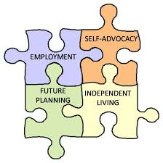

Florida School for the Deaf & the Blind
www.fsdbk12.org
207 San Marco Ave
St. Augustine, FL 32084
904-827-2200
904-827-2212

FSDB is a fully accredited, tuition-free state public school for eligible Pre-K and K-12 students who are deaf/hard of hearing, blind/visually impaired, or deafblind.

Lighthouse of the Big Bend
https://www.seeingindependence.org/
info@seeingindependence.org
301 Highland Oaks Terrace, Tallahassee, FL
850-942-3658
Lighthouse of the Big Bend serves individuals, from birth through life, who are legally blind seeking to be independent or maintain their independence after losing vision. Some of our Services: Techniques of independent daily living, Communication (reading, writing, phone), Assistive technology including computers, Orientation, and mobility (moving safely around the home and community), Employment skills, Recreation and leisure activities, Individual and family adjustment counseling.

PROJECT 10: Transition Education Network
http://project10.info/
Region 2 Northeast FL
cdetlefsen@usf.edu
904-651-2115

Project 10’s primary charge is to assist school districts in providing appropriate planning and timely transition services and programs to assist youth with disabilities in their transition to adulthood. Project 10 also serves as a collaborative resource for other state agencies, discretionary projects, non-profit organizations, and families in the provision of transition services for students served in exceptional student education.

Florida Gateway College
https://www.fgc.edu/students/student-resources/disability-services
Disability Resource Office
disability.services@fgc.edu
386-754-4393
Educates students about their legal rights and responsibilities, provides services and accommodations, and promotes self-determination and self-advocacy so that all students with diagnosed disabilities have equal access to educational opportunities and achieving their academic and personal goals.

North Florida College
disabilityresourceCenter@nfcc.edu
850-973-1683
Educates students about their legal rights and responsibilities, provides services and accommodations, and promotes self-determination and self-advocacy so that all students with diagnosed disabilities have equal access to educational opportunities and achieving their academic and personal goals.
RiverOak Technical College
http://riveroakcollege.com/
386-647-4210
RiverOak offers 19 career and technical education programs to select from that lead to industry credentials. RTC offers high quality instruction, academic and financial advisement, mentoring and coaching to ensure your success in its programs.

The Arc Jacksonville on Campus Transition at UNF

https://www.unf.edu/oncampustransition/

904-620-3890

College of Education and Human Services

coeoct@unf.edu

Provides an innovative college experience for young adults with intellectual disabilities or differences, while providing transformational learning experiences to university students, college educators, and community leaders.

Project SEARCH
Lake City Medical Center
Lake City, FL
Pam Hill
hillp@columbiak12.com
Project SEARCH is a one-year program designed for students with disabilities who have a goal of employment, have met graduation requirements and are between the ages of 18-21 years of age (preferably nearing the end of their FAPE eligibility). This national model for high school transition and workforce development provides career exploration and
training opportunities for young adults with disabilities. Participants learn complex employability and job skills while completing three, ten-week internships within a host business. Individualized job development and placement in competitive employment occurs based on each person's experiences, interests, strengths, and skills. Workplace accommodations and on-the-job coaching are provided during and after the program as needed.

Florida Coordinating Council for the Deaf and Hard of Hearing
http://www.floridahealth.gov/provider-and-partner-resources/fccdhh/
4052 Bald Cypress Way, Bin A13
Tallahassee, FL 32399
850-245-4913

A resource for deaf and hard of hearing Floridians who need assistance with everyday needs including employment,
education, and access to services. The Coordinating Council assists nearly 3 million Floridians affected by hearing loss.

Florida Diagnostic & Learning Resources System
https://www.fdlrsnefec.org/
3841 Reid Street Palatka, FL 32177
386-329-3811

Center activities focus on enhancement of learner outcomes, increased student achievement, partnerships between families and professionals, early childhood identification and evaluation, professional development, assistive and instructional technology, and interagency collaboration. Services are available to district, agency, community, and other personnel working with students with disabilities and their families.

FDLRS Multidisciplinary Diagnostic and Training Program
https://mdtp.pediatrics.med.ufl.edu/
1699 SW 16th Ave. Gainesville, FL 32608
352-294-8248

FDLRS/MDTP provides a range of services including diagnostic evaluation and consultation services for children and youth identified as having complex medical, educational, emotional, and/or behavioral problems. UF MDTP also provides consultations, technical assistance, and pre-service and in-service training for parents, teachers, other school and district personnel, and related providers and professionals.

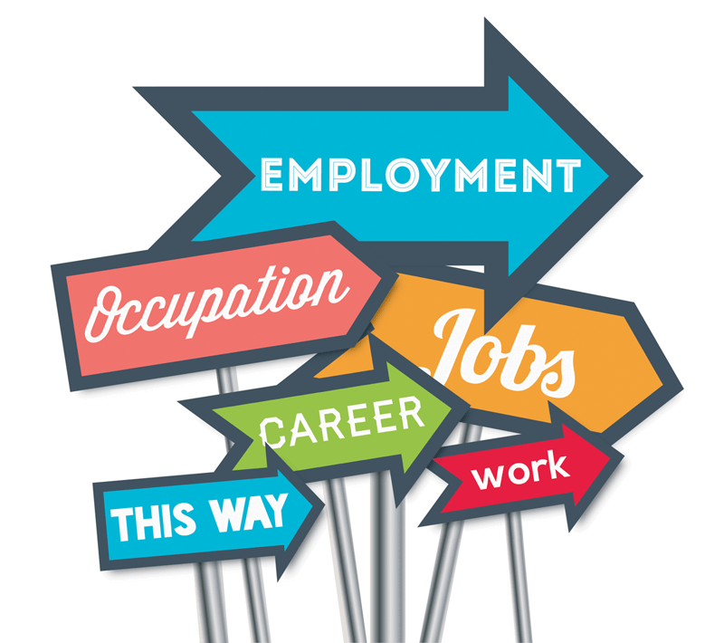

Notes:
____________________________________________________________________________________________________________________________________________________________________________________________________________________________________________________________________________________________________________________________________________________________________________________________________________________________________________________________________________________________________________________

